JUN 12 Swarthmore Professors Adapt to Online Learning
Swarthmore College

When Swarthmore College’s teaching and learning went remote because of the COVID-19 pandemic, history professor Tim Burke focused on keeping his classes simple. There are many online learning platforms available to teachers to diversify their online classes, but Burke stuck with the Moodle and Zoom programs that students already knew.
“I just decided that everyone, including me, was having platform fatigue, and it really was not the right time to ask people to have to climb a steep learning curve for a single transitory experience,” he said.
The Swarthmore College website proclaims that its community “thrives on open dialogue, shoulder-to-shoulder discovery, face-to-face exploration.” This approach, as well as the 8-to-1 student to faculty ratio, has helped the college garner a reputation as one of the top liberal arts colleges in the country. But its hands-on, intimate learning had to be modified once the college transitioned to remote learning.
The Swarthmorean explored how three instructors — teaching humanities, physical science, and performing arts — adapted their classes.
For a class on the West African slave trade, Burke combined Zoom discussion sessions with recorded lectures. Another class, about how to adapt historical events and themes for artistic work, was discussion-based and therefore relied more heavily on Zoom, which Burke found more difficult.
Burke also tried hard not to assign extra work when he revamped his syllabi for on-line instruction. His goal was “modest and adjustable expectations of students (and hope they feel the same way about me!),” he said.
Catherine Crouch, a physics professor, and Bethany Formica, an associate in performance who teaches dance, faced different challenges.
Crouch taught two labs this semester, one on electricity and magnetism, and one on quantum mechanics. Her challenge: giving students meaningful lab work when they couldn’t actually be in the laboratory.
Ordinarily, students trying to determine how much voltage is produced by dropping a magnet through a coil, for instance, would use data from experiments they performed themselves. This semester, Crouch provided data for them. Sometimes students wrote proposals for experiments to be performed by lab instructors, generating data for the students to analyze.
Crouch said her remote teaching was complicated by internet connectivity issues that sometimes affected students’ ability to access software and do group work. Class length also proved difficult. Three-hour-long labs are “great when you’re actually in the lab doing work,” Crouch said. “But it’s hard to concentrate for that long when you’re sitting by yourself working at a computer.” (She built in stretch breaks.)
Ultimately, Crouch feels the students did some meaningful science. But the lack of hands-on lab work “limited the educational experience.”
Sophomore Elizabeth Mickelson, enrolled in both of Crouch’s labs, agreed that there were some problems with moving online. “The biggest difficulty was that, because we didn’t actually get to do the experiments, it was harder to connect the data we analyzed to the theoretical concepts we tested.” She agreed that being physically absent from the lab made it harder to concentrate.
There were compensations, Mickelson noted. Students had more time for experimental design, data analysis, and scientific presentation. Overall, she found the labs worthwhile.
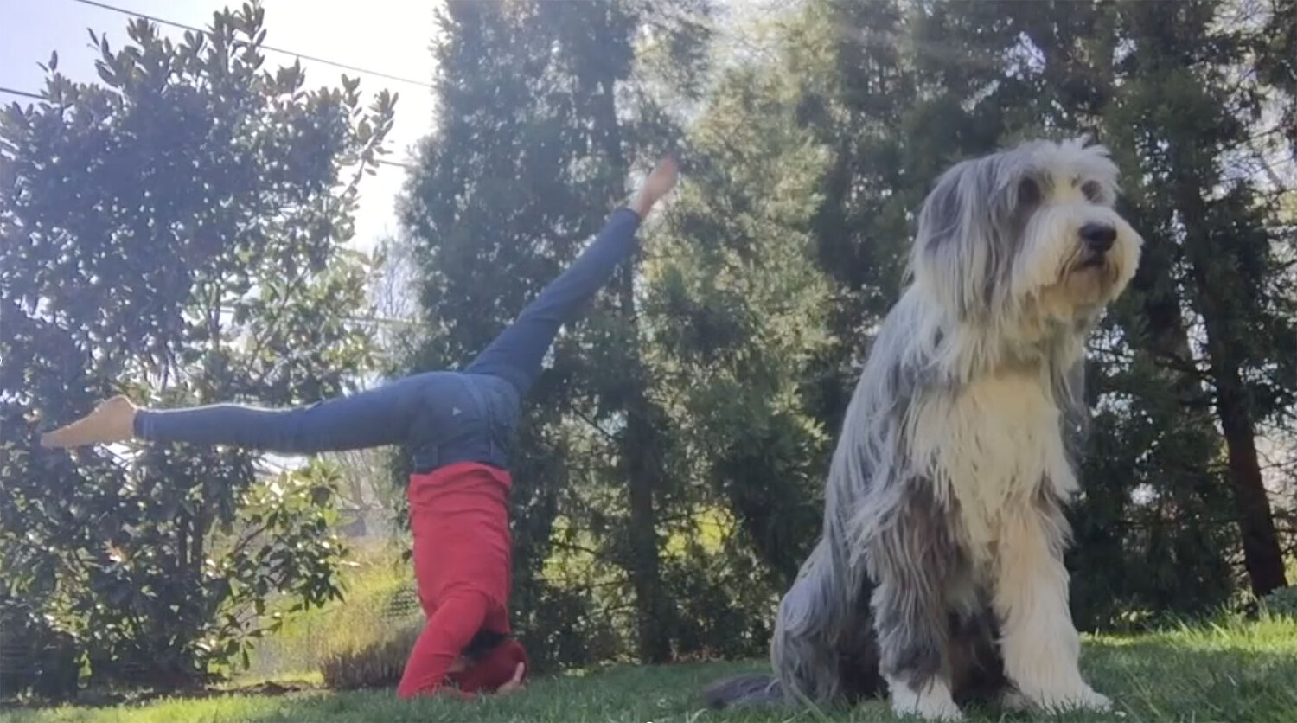
Bethany Formica made a series of “love note” videos to send to her Swarthmore College dance students.
Bethany Formica, who teaches at both Swarthmore and Bryn Mawr colleges, found that teaching dance remotely presented a huge learning curve. Instead of being in a studio with her students and an accompanist, she pre-recorded and uploaded classes to accommodate students in different time zones. She had to acquire music rights and learn how to close-caption her videos.
That students’ different economic situations gave them unequal access to the internet also posed problems.
Formica found it difficult to adjust instructions in response to student feedback when online. “3D movement becomes flat, left and right can be hard to identify, and movement that isn’t frontal is difficult to teach,” Formica said. “Everything takes twice as long to learn.”
Her Bryn Mawr class was able to meet on a weekly Zoom call, but the students in her Swarthmore modern dance class were spread over too many time zones to make live class meetings feasible. Instead, Formica devised a “Choose Your Own Adventure” model, asking students to select 12 virtual assignments out of 30 choices, to complete on their own schedule.
These assignments ranged from completing prerecorded classes and following yoga videos on YouTube to watching documentaries about dance. After completing assignments, students emailed their thoughts to Formica.
She also created dance videos she called “love notes” to send to her students. Not related directly to the class, these showed Formica doing yoga or dancing in her backyard, her dog by her side. She sent them to cheer up her students.
Senior Shayne Rothman thought Formica’s assignments worked well. She said Formica “made the course accessible to everyone, since you could do it on your own time. And everything she assigned felt like genuine learning experiences rather than busy work.”
Formica found some benefits to teaching remotely. “I got to know most of my students in a new way through email, and their exceptional writing about the dance assignments they chose,” she said. “We don’t often have a lot of opportunity to speak in class, since we are moving most of the time.”
Despite this, she felt online teaching took away from the community-building aspect of dance.
“The studio is a place to learn, to make mistakes together, to feed off each other’s energy, to encourage each other with a smile from across the room, or to try something new,” she said. “I look forward to the time when we can once again share real space and time together.”
Elisabeth Miller is a rising senior at Swarthmore College double majoring in English and history. She interned at the Swarthmorean this spring with funding from Swarthmore’s English Department and the Lang Center for Civic and Social Responsibility.

